UNIT-VI
SCADA

COMPUTERCONTROLOFPOWERSYSTEMS:MainTasksinPowerSystem Operation, SCADA:Division ofTasksbetweenVariousControl Centers,FeaturesofSCADASystems, SCADAConfiguration,EnergyManagementSystems,System operatingstates,System Security,StateEstimation.
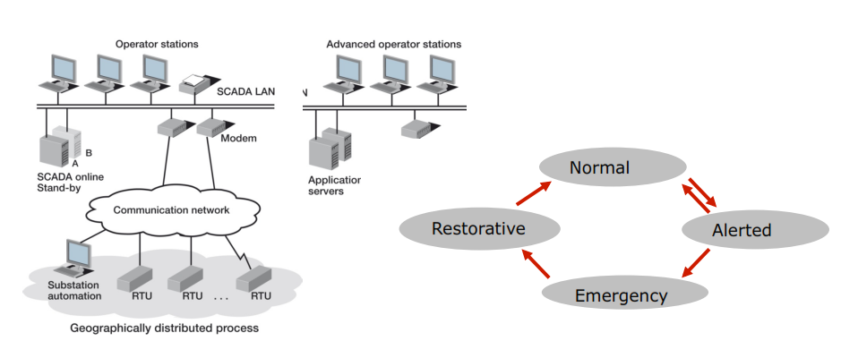

SCADA DEFINITION
SCADAstands forSupervisoryControlandDataAcquisition.
SCADArefers to a systemthat collectsdatafrom varioussensorsat a factory,plantor inother remote locations andthen sendsthis datato a centralcomputer whichthenmanagesand controls thedata. (OR )

DefinitionofSCADA:A collectionof equipment that will provide anoperat or at remote location with enoughinformationtodeterminethestatusofaparticularpieceofaequipmentorentiresubstation andcauseactionstotakeplaceregardingtheequipmentornetwork.
Thefeedbackcontrollooppasses throughtheremoteterminalunit(RTU) or Programmablelogiccontroller (PLC), whilethe SCADA.
Forexample:
APLCmay control theflowofcoolingwaterthroughpartof anindustrialprocess, but the SCADAsystemmay allowoperatorsto changethe setpointsfor theflow, and enablealarmconditions,suchas loss offlowandhightemperature,to be displayedandrecorded.
Most essentiallytheSCADAsystemconsists of three fundamentalcomponents
1.Master station(MS) or CentralMonitoringSystem(CMS),
2. Communicationlink
3. RemoteTerminal Unit (RTU) or a ProgrammableLogicController(PLC).
ACentralMonitoringSystem(CMS),containedwithinthe plantand oneor more Remote Stations.TheCMS housesthe ControlServer andthe communications routersvia a peer-to-peernetwork.
TheCMS collectsand logsinformation gatheredby the remotestations andgeneratesnecessaryactionsforevents detected.
Aremotestation consistsof eithera RemoteTerminal Unit (RTU) or a ProgrammableLogicController(PLC) whichcontrolsactuators andmonitors sensors.
Typically,remotestations havethe addedcapabilitytobeinterfacedby field operators via handheld devicesto perform diagnosticandrepairoperations.
Thecommunicationsnetworkis the mediumfortransportinginformation betweenremotestations andthe MS.Thisis performedusingtelephoneline, cable,or radiofrequency.
If the remotesite is tooisolatedto bereachedvia directradiosignal,a radiorepeateris usedto link thesite.
Simulationtools usedtoaidthe operatorinpreventingdisturbances. Simulationis used whenthe systemwhichis to beanalyzeor designis complex to useanalyticaltechniques(likeaerodynamics).

SCADASYSTEMS
ASCADAsystemrefertoasystemconsisting ofanumberofremoteterminalunits(orRTUs) collectingfielddataconnectedbacktoamasterstationviaacommunications system.
Themaster stationdisplays theacquired dataandalsoallowstheoperator toperformremote controltasks.The accurateandtimelydata(normallyreal-time)allowsforoptimization oftheoperationoftheplantand process.
Afurtherbenefitismoreefficient,reliableandmostimportantly,saferoperations.Thisallresultsinalowercostofoperationcomparedtoearliernon-automatedsystems.
AsuccessfulSCADAinstallation dependsonutilizingprovenandreliabletechnology,withadequate andcomprehensivetrainingofallpersonnelintheoperationofthesystem.
The RTUprovidesaninterfacetothefield analogand digitalsignalssituatedateachremotesite.
The communicationssystemprovidesthepathwayforcommunicationsbetweenthemasterstationand theremotesites.
Thiscommunication systemcanberadio,telephoneline,microwaveandpossibly evensatellite.
Specificprotocolsanderrordetectionphilosophies areusedforefficientandoptimum transferofdata.
Themasterstation(andsub-masters) gatherdatafromthevariousRTUsand generallyprovideanoperatorinterfacefordisplayofinformation andcontroloftheremotesites.
In largetelemetrysystems,sub-mastersitesgatherinformationfromremotesitesandactasarelay backtothecontrolmasterstation.

APPLICATIONS OF SCADA
SCADAiswidelyusedindifferentareasfromchemical,gas,water,communicationsandpower systems.ThelistofapplicationsofSCADAcanbelistedas follows.
1.Electricpowergeneration,transmissionanddistribution:ElectricutilitiesuseSCADA systemstodetectcurrentflow and linevoltage,tomonitortheoperationofcircuitbreakers,and totakesectionsofthepowergridonlineoroffline.
2.Water,WasteWaterUtilitiesandSewage:StateandmunicipalwaterutilitiesuseSCADAto monitorandregulatewaterflow,reservoirlevels,pipepressureandotherfactors.
3.Buildings,facilitiesandenvironments:FacilitymanagersuseSCADAtocontrolHVAC, refrigerationunits,lightingandentrysystems.
4.Oil andGasTransportation&Distributions:
5.WindPowerGeneration
6.CommunicationNetworks:
7.IndustrialPlantsandProcessControl:
8.Manufacturing:SCADAsystemsmanagepartsinventoriesforjust-in-timemanufacturing, regulateindustrialautomationandrobots,andmonitorprocessandqualitycontrol.
9.MasstransitandRailwayTraction:TransitauthoritiesuseSCADAtoregulateelectricitytosubways,tramsandtrolleybuses;toautomatetrafficsignalsforrailsystems;totrackand locatetrainsandbuses;andtocontrolrailroadcrossinggates.
10.Trafficsignals:SCADAregulatestrafficlights,controlstrafficflowanddetectsout-of-order signals.

MAINTASKSIN POWERSYSTEM OPERATION:
Themaintasksofpowersystemcanbedividedintothefollowingcategories:
1.Planningof operations
2.Operationalcontrol tasks
3.Operatingaccountingandfinancialcontrol
TheabovetasksareperformedbytheNationalcontrolcenter,Regionalcontrol center,DistrictcontrolcenterandMajorsubstationcontrolrooms.

1)Planningof operations:
Planningmeanstheformulatingandpreparingactionsbeforeputintotheuse. Planningisdonefor nexthour,nextday,nextweek,nextmonth,andnextyear and forlongrange.Planningtasksincludes:
- Thenationalloadcenterperformsthefollowingtasks:
Allloadpredictionfollowedbygeneratorscheduling,spinningreserves, planningofreserves,planningofmaintenanceschedules,planningofenergy resource,selectionofenergyresource,hydro-thermalgenerationco-ordination, planningofpowerexchangeb/wtwo regionsandplanningofinstallationofHVDC lines.
- TheRegionalloadcenterperformsthefollowingtasks:
allloadpredictionfollowedbygeneratorscheduling,planningofreserves, planningofmaintenanceschedulesandselectionofloadscheduling.
- TheDistrictloadcenterperformsthefollowingtasks:
allshorttermplanningintermsofregionallevelplanningandthenfollowed byplanningofgenerationandreserves,andplanningofloadsheddingindistrict.
- ThePowerstationandsub-stationcontrolroomperformsthefollowingtasks: Workplanningfor hourly,daily,weekly,monthly.
2)Operationalcontrol tasks:
Anelectricsupplycorporationbasicallymust meet the followingaims:
-Theremustbe continuityof the powersupplyfor the consumer.
-Thenetworkwillbe designedin sucha mannerso as tocoverthemaximumconsumers.
-Maximumsecurityof supply
-Lesspossibilityof the fault
-Maximumefficiencyofthe plant
-Consistency of the frequency
-Consistency of the voltage
-Supply powerat low cost
Thenationalload centerperformsthe followingtasks:
-Accuracyof generation,andloadandfrequency
-Powerexchangeunderemergencycase
-Systemfrequencycontrol
TheRegionalload centerperforms the followingtasks:
-Accuracyof generation,loadandfrequencyandpowerexchangeb/w districts underemergency.
TheDistrict load centerperforms the followingtasks:
-Accuracyandcontrolofgenerationindistrict
-Control ofpowerstation
-Control ofT/Landtie-lines
Thepowerstationand sub-station control roomperforms the followingtasks:
-Generation,start, stopfunction
-Automaticrestorationfunction
-Control andprotectionfunctions
Maintenance
Thetransmissionsub-station performs thefollowingtasks:
-Switchingoperation
-Protectivefunctions
-Voltage control andreactivepowercompensation
-Datacollection
-Loadsheddinginstructions.
3)Operating accounting and financial control:
Theoperatingaccountingdealswiththe data collectionand evaluation and then preparationof thefinancialreportsand billings. Thetask includesfirst ofall the datacollectionregardingthe powerproduced,and thenbillingonthat powerinterchangefor adjacentstation, thenestimate theperformanceof thepowerstation, then estimatethe priceofthe poweravailablefor the consumer.

TECHNICALFUNCTIONSOFSCADA:
Proper and efficient energy management system requires lot ofdata about operating conditions. Many operations have to be carried out at unattended locations from operating center. In many situations operations such as opening or closing a circuit breaker etc. have to be carried out but the cost of providing operating personnel may be prohibitive. If an operator has to go from the control center to the site to perform such operations there would be considerable delay. Such delays result in long outage durations and poor reliability. SCADA systems have been developed to overcome such problems. The need to control remote operations and monitor them led to development of SCADA.
TheSCADAsystemprovidesthe followingfunctions:
Data acquisition:
Thebasicinformationof thepowersystemcollectedis calledthe DataAcquisition. Thedata is collectedby means ofCTs, PTsandtransducers.It providesthe telemetrymeasurementand status indicationto theoperator.
Supervisorycontrol:
Itenablesthe operatortoremotelycontrolthe devices.For exampleopenand close of the circuitbreaker.
Tagging:
Itpreventsthe devicefromunauthorizedoperation.Meansitauthorizesthe device
toperform thespecificoperation.
Alarms:
Itinforms theoperatoraboutthe unnecessaryevents andundesiredconditions.
Logging(Recording):
Itlogsall the operatingentry,all alarmsandother information.In other wordsit keeps therecord ofallthe events.
Loadshedding:
Itprovidesboththe automatic andmanualcontroltrippingof loadduringthe emergency.
Trending:
Itplots themeasurementontheselectedtime scale.

SIMPLELAYOUTOF THESCADA
Thesimplelayoutofthe SCADAsystemwithits essentialfeaturesis shown
below in thefig:

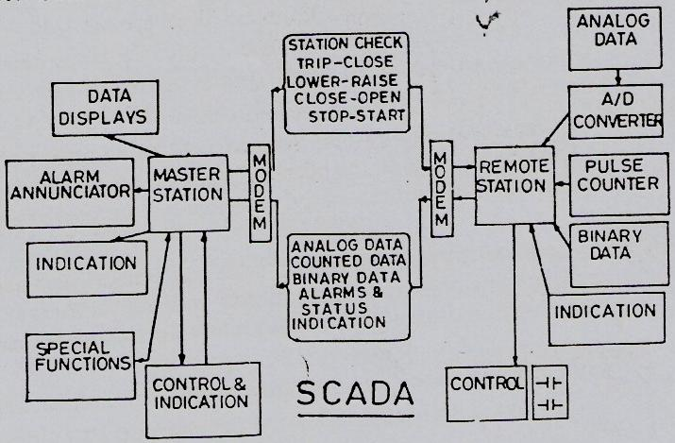

TheSCADAsystemenablesthe operatorto attainthecompleteknowledgeofthesystemina single roomby means of display.
Almost allthe SCADAsystemsarecomputer based(Digitalcomputer).This computer is locatedinthemaster unit.
Themaster unitis the heart ofthe SCADA system,it comprisesmany of thei/p ando/p equipmentto receiveandsend the control messagefromandto theRTU.
Allthe dataofoperationsof RTUaretransmittedtothe master controlunit and aftercollectingthe informationthe data arefeedback to theRTU.
Alsomaster unitconsists ofseveralmodems whichareused to convert thedigital intoanalogor analoginto digitalmessagedependinguponthe requirement.
The received informationofthe master unitis displayedonVDU andthen is printedforpermanentrecord.
Inadditionthe SCADAsystemalsocomprisessomemore peripheralequipment suchas controlconsole,VDU,Alarms,Printers,D/Aconverterand Recording instruments.
VisualDisplayUnit (VDU) replacesmimic boardto representone linediagram, tabular display,bar charts,curves andevent lists andusedforentering commands to system.
Modernsystemincludesthe colordisplaywhichis usedto distinguishb/w the different voltagelevels.
Alsodifferentcolorsdifferentiatethe operatorto understandthe openand closeof CB,alsothe flashingindicationcanbemade whichdeterminesthe changeofthe state ofany device.
Theaudiblealarmscanbe usedto alert theoperatorfrom thefault or condition.
Theprintersare usedtohavethepermanentrecordsoftheevents.
TheD/A converter are usedtoconvertthe digitalinformationintothe analoginformation, and then theinformationis suppliedto theindicatingor therecordinginstruments.
Therecordinginstrumentsareused to store thedata of eachremote station unit.

FEATURESOF SCADA:
- Dynamicrepresentation
- Databaseconnectivity
- Deviceconnectivity
- AlarmsTrends
- Sports
- Trends
- Scripts
- Security
- RecipeManagement
- Networking

NEED FOR SCADA
The main reasons for adopting SCADA are as under:
- To reduce cost
- To reduce man power
- To reduce future capital requirements
- To improve level of service
- To avoid environmental accidents
- To comply with regulator requirements
- To attain and maintain competitive edge
- To replace existing aging system
- To manage complex systems

COMPONENTS OF SCADA
A SCADA system has the following components
1. Sensors:- (digital or analog) and control relays which interface with the power system.
2. Remote terminal units (RTUs): There are small computerised units deployed in field at specific sites and locations. RTUs are collection points for getting information and reports from sensors and for sending commands to relays.
3. Master unit: Large computer system which serves as a central processor.
4. Communication Links.
5. Software.

CONFIGURATIONS
SCADA system may have different configurations depending on the system and its requirements. Each configuration consists of a master unit (M) and remote unit (R).
Fig. (a) shows a one to one SCADA configuration. It has a master unit for each remote unit.
Fig.(b) shows star configuration with master unit at a central location and remote units branched out. The number of remote units may be any depending on the power system. However each communication channel has one remote. It is also called hub configuration.
Fig. (c) shows a configuration called party line configuration. In this configuration there may be many remote units on a communication channel.
Fig. (d) shows a network configuration.
It has one master unit (M), several communication channels and many remotes on each channel. It is a combination of star and party line configurations.
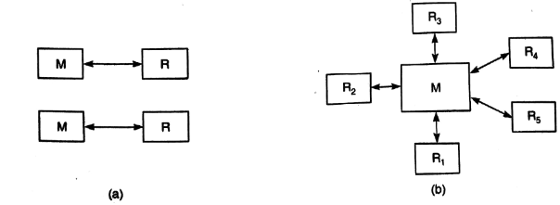
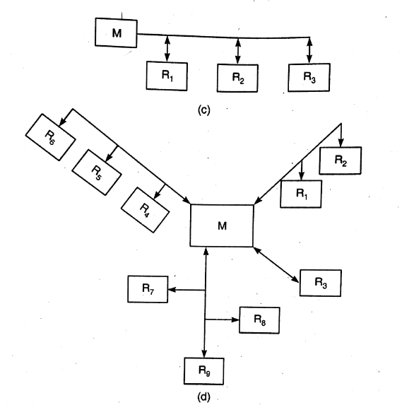

ENERGY MANAGEMENT SYSTEM (EMS)
The installed generation capacity, in India, has increased from about 1710 MW in 1950 to about 140000 MW in 2009. The electrical energy generated annually has increased from about 5 x 109 kWh in 1950 to about 700 x 109 kWh in 2009.
The per capital consumption has increased from 15.6 kWh in 1950 to about 700 kWh in 2009. Yet every state is facing shortage of electrical energy. The peak time power shortage is about 13% and energy shortage is about 8%. Only about 50% of population has access to electrical energy. The reason for shortages can be attributed to the fact that generation, transmission, distribution and utilization of electrical energy is not being managed properly.
Energy management system is an interactive energy management tool that helps trackenergy usage and reduce wastage.
It can be described in terms of its application to electric utilities (who manage generation, transmission and distribution of electric energy) and users (industries, commercial hours etc.) SCADA is used for both these categories.
Energy Management System for Utilities: EMS for generation; transmission and distribution systems uses SCADA (and some other softwares) for monitoring the 'system, state estimation, security analysis and contingency analysis. It attempts at one or more of the following.
1. Economic dispatch.
2. Unit commitment.
3. Network improvement solutions.
4. Asset management.
5. Loss identification and reduction.
6. Automatic remote meter reading, installation of new meters, retrofitting of existing meters, on line checking of utility meters.
7. Remote monitoring of important distribution parameters.
8. Improvement of data accuracy.
9. Analysis of maintenance schedules.
10. Record of daily sequence of events
11. Analysis of capacity utilisation
12. Analysis of power quality problems like voltage sags, THD etc.
13. Accurate demand prediction,
14. Load shifting to reduce peak time power shortage.
15. Better utilisation of manpower and cost reduction.
16. Meter data analysis through energy management software, energy accounting software, distribution network analysis software, feeder analysis software, capacitor optimisation software etc. etc.
Energy Management System for Users: Energy management systems for large users envisages demand side management, energy conservation, energy auditing etc. Development of cogeneration, capative power generation also form part of energy management systems.
The aims are:
1. Purchase of energy at lowest cost.
2. Maintain high efficiency of equipment
3. Reusing and Recycling of energy by cascading (e.g. waste heat recovery)
4. use or more appropriate technology
5. Demand control.
6. Accurate energy accounting
7. Increased productivity.
8. Loss identification and management.
9. Better utilisation of manpower.
10. Monitoring and improving power factor.
11. Monitoring specific energy consumption
12. Analyse maintenance and repairschedules.
The basic principles of energy conservation include maximum energy efficiency and maximum cost effectiveness in energy use. Energy conservation planning includes specifying energy conservation targets, identifying energy inefficient facilities, adoption of energy conservation measures and evaluating energy conservation benefits.
Demand side management involves all activities which involve actions by the user. The scope of DSM includes load management, increased electrification, developing DSM programs, peak clipping, valley filling, load shedding, strategic energy conservation, strategic load growth etc.
Energy audit is an important part of energy management system. It involves carrying out a continuous systematic procedure for plant energy study and analysis of energy utilisation in the plant.
It aims to find out how much energy is being used in the plant, how much should be used and to what extent can energy requirement be reduced by using energy efficient procedures and devices.
The quality and quantity of energy input and energy consumption is taken into account. A large number of instruments (electrical, lighting, temperature chemical, mechanical) and measurements are needed for detailed energy audit of a large industrial installation.
EMS for industries also uses tools like SCADA and many other softwares.

SYSTEM OPERATING STATES( TRANSITION DIAGRAM)
Fig shows the different states in which a power system may exist at different times. For over 98% of time it exists in normal state. However sometimes the system may go to alert and other states. The transition diagram depicts the transition of the system from normal to other states and back.
Whenthe system is in normal state the generation matches the load. This equality is shown by the alphabet E in transition diagram. Another symbol used in this diagram is I. This symbol denotes that none of the equipment (generators, lines, transformers etc.) is overloaded.
In normal state both these conditions are met with and therefore E and I are mentioned in the diagram for normal state. denotes that equality between generation and load is disturbed. Similarly, denotes that some equipment is overloaded.
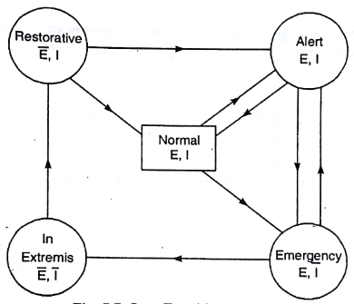
Fig : State transition Diagram

When in normal state the system is secure and some amount of spinning reserve also exists. When a small decrease in generation occurs or some other disturbance takes place, the system may go to 'Alert' state. However the system is synchronised but the security level is reduced below the specified limit. But generation and load are matching and none of the equipment is overloaded.
Some corrective action is initiated and system may go back to normal state. However if preventive action is not successful or if disturbance is severe, the system may go to 'Emergency' state. If the disturbance is severe the system may transition directly from normal to 'Emergency' state.
In emergency state also the system is synchronised but some equipment may be overloaded (symbolsanddenote these condition). Some emergency control action are needed if the system enters emergency state. If these emergency control action fails, the system may transition to in ‘Extermis’ state.
When in this state the synchronisation is upset and the system gets disintegrated into islands. The generation and load matching so longer exists and overloading of equipment may also occur. This state is characterised by symbols and. This state may witness tripping of one or more generators (due to overloading) and some lines may also get tripped.
Some parts of the country (or province) may also face black out if the system is in In Extremis'. The conditions which force the power system to go from 'Normal' to 'In Extremis' may last for a few seconds or a few minutes.
The power system engineers have to take some very important corrective actions to take the system to 'Restorative' and then to 'Normal' state. This process may take many hours or even days.
Turbines have to be restarted and generators have to be synchronised again. The islands, in which the system has disintegrated, have to be connected again and lost loads have to be picked up.
The control strategies which are adopted when the system is not in 'Normal' state can be summarised as under.
Alert state:
Preventive control to restore adequate reserve generating margin, generation shifting, tie line rescheduling, voltage reduction (if extremely necessary).
Emergency state:
Immediate control to clear equipment overloads, fault clearing, fast valving dynamic braking, exciter control, load control, capacitor switching and all controls mentioned in 'Alert' state.
In Extremes:
Heroic action to control disruption of entire system, Load shedding, controlled islanding and all controls mentioned in 'Emergency State'.
Restorative:
Corrective control to re-establish viable system, generating units restarting and synchronisation, load restoration, re-synchronisation of different islands and areas.

SECURITY ANALYSIS
System security can be broken down into two major functions that are carried out in an operations control centre (i) security assessment, and (ii) security control. The former gives the security level of the system operating state. The latter determines the appropriate security constrained scheduling required to optimally attain the target security level.
The security functions in an EMS can be executed in 'real time' and 'study' modes. Real time application functions have a particular need for computing speed and reliability.
The static security level of a power system is characterised by the presence or otherwise of emergency operating conditions (limit violations) in its actual (pre-contingency) or potential (post-contingency) operating states. System security assessment is the process by which any such violations are detected.

System assessment involves two functions:
(i) System monitoring and (ii) Contingency analysis. System monitoring provides the operator of the power system with pertinent up-to-date information on the current conditions of the power system. In its simplest form, this just detects violations in the actual system operating state.
Contingency analysis is much more demanding and normally performed in three distinct states, i.e. contingency definition, selection and evaluation.
Contingency definition gives the list of contingencies to be processed whose probability of occurrence is high. This list which is usually large, is in terms of network changes, i.e. branch and/or injection outages.
These contingencies are ranked in rough order of severity employing contingency selection algorithms to shorten the list. Limited accuracy results are required, therefore an approximate (linear) system model is utilized for speed.
Contingency evaluation is then performed (using AC power flow) on the successive individual cases in decreasing order of severity. The evaluation process is continued up to the point 'where no post-contingency violations are encountered. Hence, the purpose of contingency analysis is to identify the list of contingencies that, if occur, would create violations in system operating states. They are ranked in order of severity.
The second major security function, security control, allows operating personnel to change the power system operation in the event that a contingency analysis program predicts a serious problem, should a certain outage occur. Normally the security control is achieved through SCO (security constrained optimization) program.

STATE ESTIMATION
The power systems all over the world have expanded considerably during the past few decades. In general a power system may have about 6 generating plants with a total of about 25 generators, about 50 buses and an equal number of HV and EHV lines.
The operation and control of such a system is a complex task. The requirements of reliability, economic operation and security even under the most difficult situations makes the job of power system engineers really cumbersome.
SCADA systems are used extensively by every utility to monitor the performance of the system. The data as obtained by SCADA system is used to take decisions in emergency state.
To ensure correct decisions it is necessary to know the existing state of the system. The state variables are the voltage magnitudes and phase angles at the buses.
The inputs to the load flow analysis are the P and IVI at generator buses (PV buses) and P and Q at load buses. If this complete information is not available, the load flow analysis cannot be made. Moreover it is possible that there may be errors in these input quantities.
The state estimation process is meant to determine the best possible estimates of voltageMagnitudes and phase angles recognising the fact that some of the inputs (obtained from measurements by SCADA instruments) may be erroneous and there may also be redundant measurements.

